Mongo Db Connection locally v1

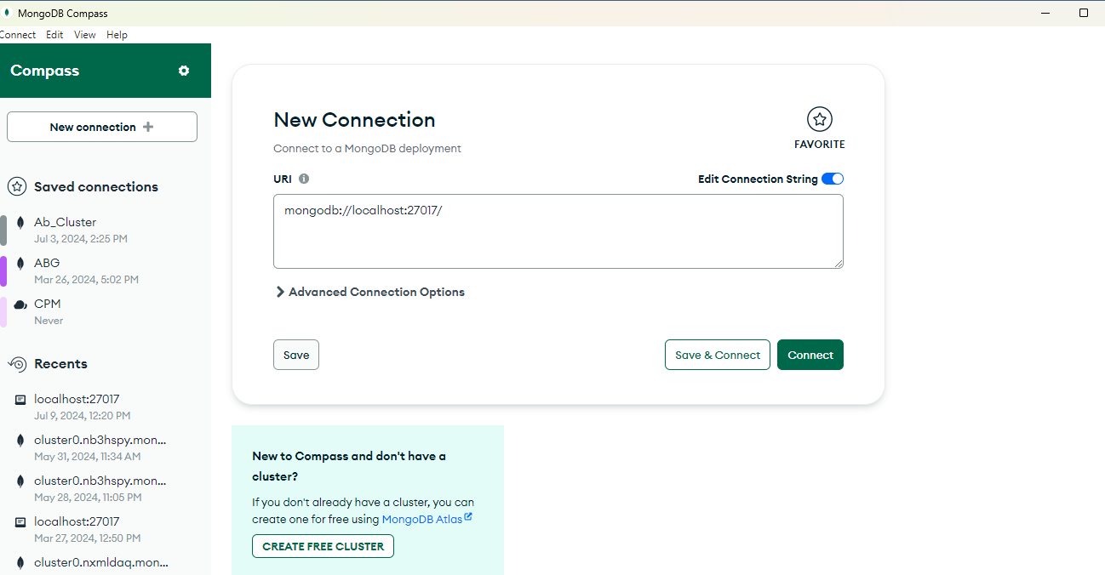

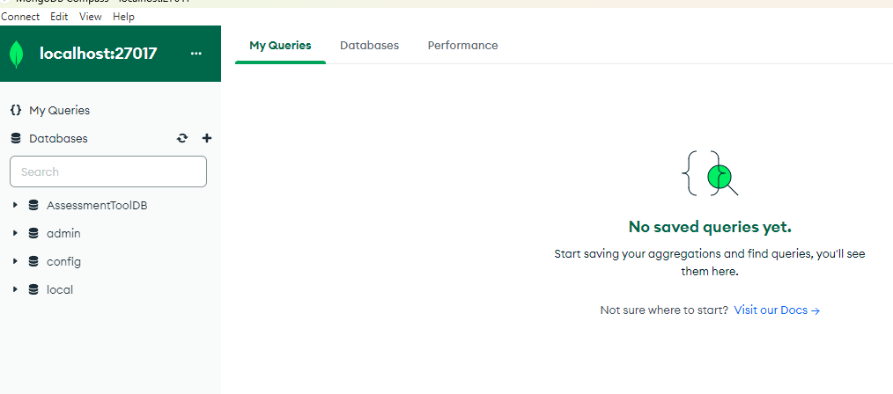

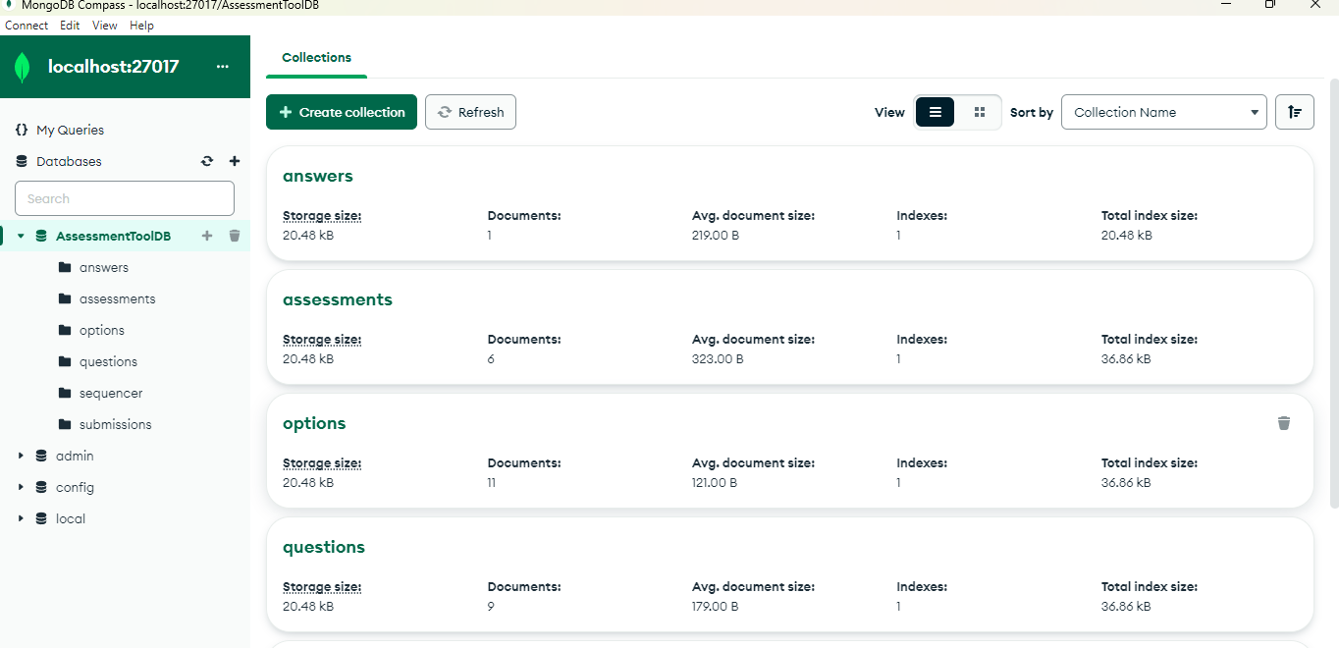

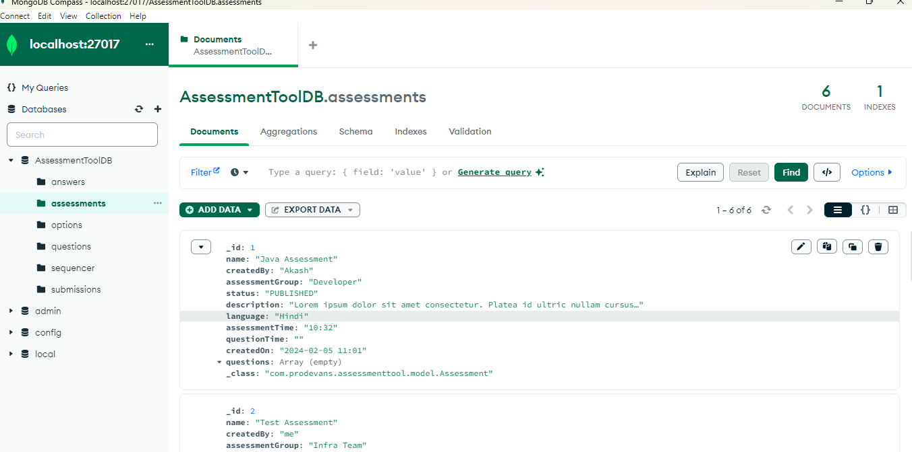

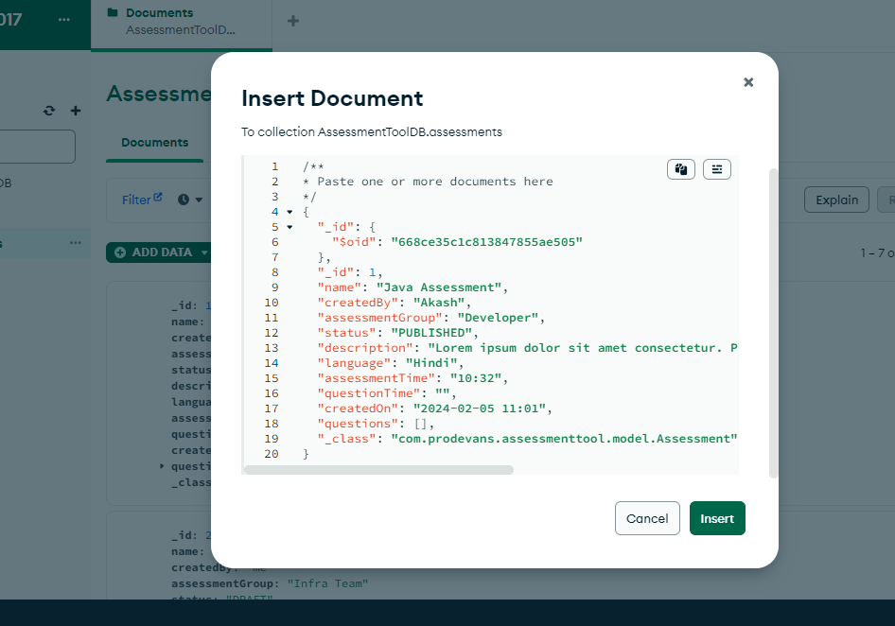

/**

* Paste one or more documents here

*/

{

"_id": {

"$oid": "668ce35c1c813847855ae505"

},

"_id": 1,

"name": "Java Assessment",

"createdBy": "Akash",

"assessmentGroup": "Developer",

"status": "PUBLISHED",

"description": "Lorem ipsum dolor sit amet consectetur. Platea id ultric nullam cursus. Dictum nisi donec urna.",

"language": "Hindi",

"assessmentTime": "10:32",

"questionTime": "",

"createdOn": "2024-02-05 11:01",

"questions": [],

"_class": "com.prodevans.assessmenttool.model.Assessment"

}

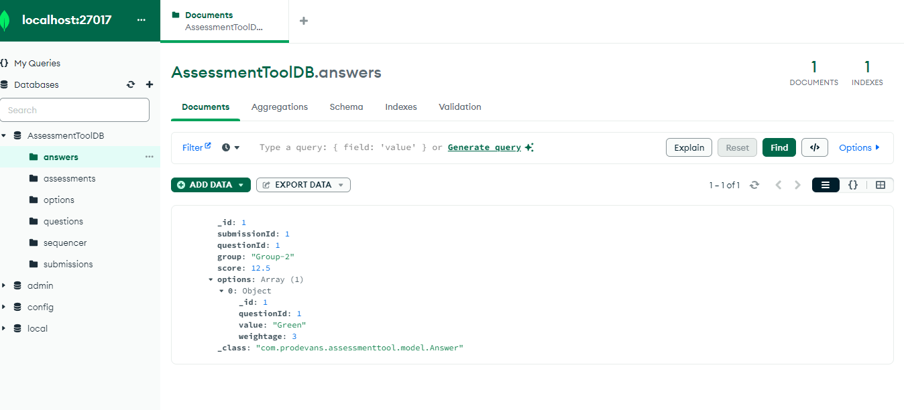

{

"_id": 1,

"submissionId": 1,

"questionId": 1,

"group": "Group-2",

"score": 12.5,

"options": [

{

"_id": 1,

"questionId": 1,

"value": "Green",

"weightage": 3

}

],

"_class": "com.prodevans.assessmenttool.model.Answer"

}

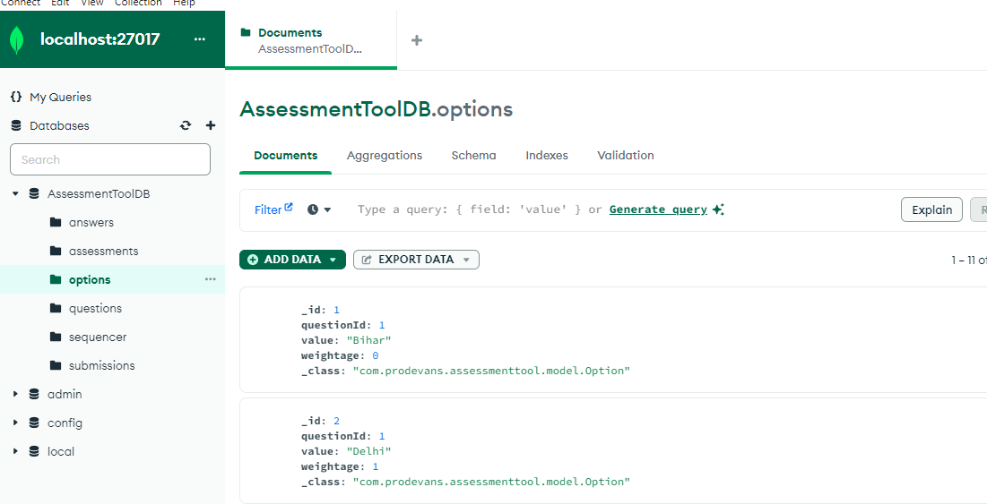

{

"_id": 1,

"questionId": 1,

"value": "Bihar",

"weightage": 0,

"_class": "com.prodevans.assessmenttool.model.Option"

}

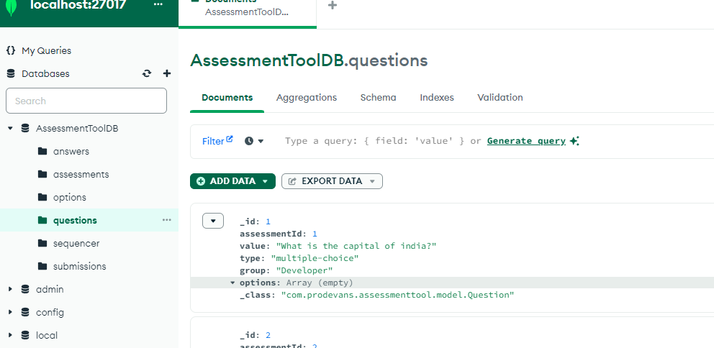

{

"_id": 1,

"assessmentId": 1,

"value": "What is the capital of india?",

"type": "multiple-choice",

"group": "Developer",

"options": [],

"_class": "com.prodevans.assessmenttool.model.Question"

}

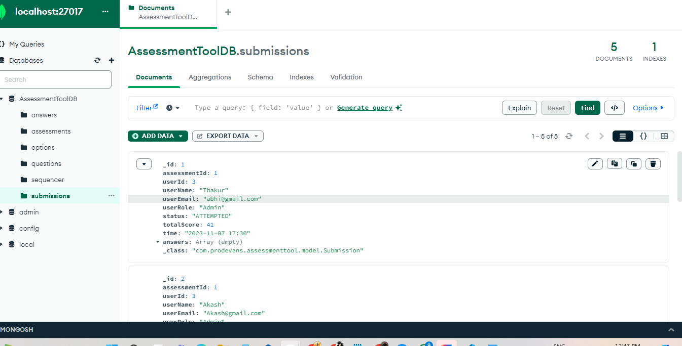

{

"_id": 1,

"assessmentId": 1,

"userId": 3,

"userName": "Thakur",

"userEmail": "abhi@gmail.com",

"userRole": "Admin",

"status": "ATTEMPTED",

"totalScore": 41,

"time": "2023-11-07 17:30",

"answers": [],

"_class": "com.prodevans.assessmenttool.model.Submission"

}

